Amazon RDS -   
It is a relational database, RDS is fully managed fast and creditable performance.  
RDS is simple and scalable.  
RDS is low cost and pay for what we use.  
Eg – MySql, Postgrace SQL, MariaDB, Oracle, Amazon Aurora  
  
Amazon Aurora -   
Is RDS reinvented for cloud, Aurora is 5 times better performance than MySql. It supports PostgreSQL and MySQL.  
Aurora is available at 1/10 cost of commercial db.  
  
RDS -   
It is easy to administer, RDS is highly scalable.  
RDS is available & durable.  
RDS provides a feature called read replica.  
Read Replica – Amazon RDS synchronously replicates the data to a standby instance in a different availability zone.  
  
Amazon RDS supports most demanding applications and is fast.  
It is made easy to control n/w access to your db.  
Amazon RDS let you to run your database in your instance in VPC.  
It isolates db and make it secure.

RDS Deployment types –

Read Replicas:   
  
Read workload of your DB.  
Can create up to 5 read Replicas.  
Data is only written to the main DB.

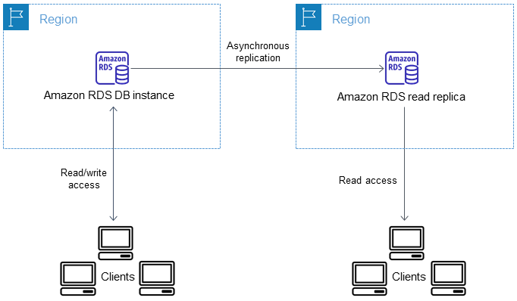

Multi – AZ:  
  
Failover in case of AZ outage (high availability)  
Data is only read/written to main database  
Can only have 1 other AZ as failure.

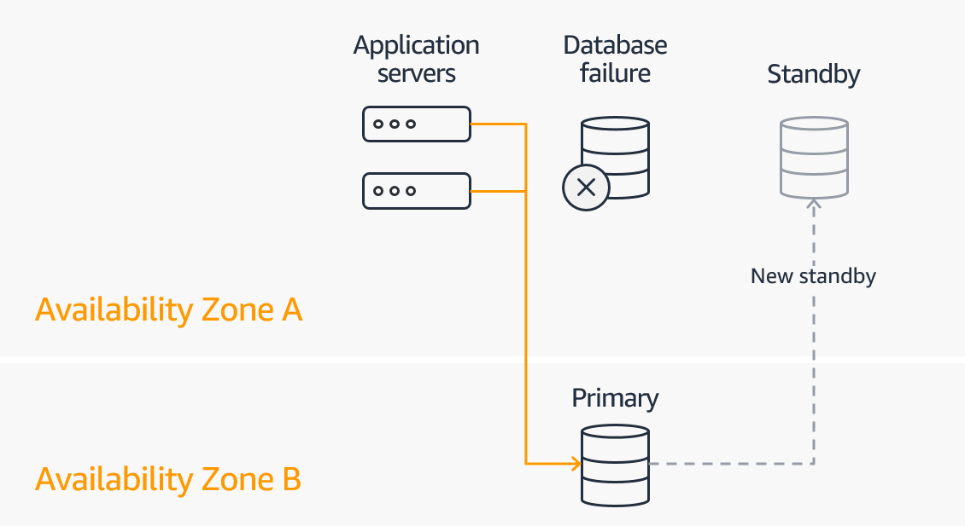

Dynamo DB -

DynamoDB is a fully managed, highly available database with replication across three availability zone.  
It is part of the NoSQL database family, so it's not a relational database.  
DynamoDB is one of the flagship product of AWS. It scales to massive workload and it's distributed serverless database, that means that we don't provision any servers.   
With RDS or with ElastiCache, we need to provision a instance type, but with DynamoDB we don't. So it's called a serverless database.  
Has low cost and auto scaling capabilities. A standard and infrequent access, IA, table class based on how you want to classify the data for cost saving.

Use cases -

Develop software applications - Build internet-scale applications supporting user-content metadata and caches that require high concurrency and connections for millions of users, and millions of requests per second.

Create media metadata stores - Scale throughput and concurrency for media and entertainment workloads such as real-time video streaming and interactive content, and deliver lower latency with multi-Region replication across AWS Regions.

Deliver seamless retail experiences - Use design patterns for deploying shopping carts, workflow engines, inventory tracking, and customer profiles. DynamoDB supports high-traffic, extreme-scaled events and can handle millions of queries per second.